International Employee Immigration Data Management

Milestone: MySQL Implementation

Group 4

Amogha Gadde  
Abhishek Kumar Sinha

857-693-9502   
857-961-6419

gadde.am@northeastern.edu  
sinha.ab@ northeastern.edu

Percentage of Effort Contributed by Amogha: 50%

Percentage of Effort Contributed by Abhishek: 50%

Signature of Student 1: Amogha Gadde

Signature of Student 2: Abhishek Kumar Sinha

Submission Date: December 3, 2023

***International Employee Immigration Data Management***

Amogha and Abhishek

As a product-based company, Company X needs access to its employee immigration data for the critical functions of visa and green card sponsorship, guaranteeing strict adherence to legal standards and successfully navigating the challenging immigration processes. The organization can effectively manage work permit visas, green card sponsorships, and visa renewals by taking advantage of this database. This proactive approach not only protects the company from potential legal snares and penalties, but it also promotes workforce stability and continuity, enabling them to maintain their valued talent pool and greatly contribute to their growth and success within the United States. Furthermore, the diligent maintenance of accurate immigration records ensures that every employee has complete authority to work in the US, supporting an even more reliable and compliant staff.

Theory of ***International Employee Immigration Data Management***:

The company has seven departments: Software development, Data Science, Finance & Accounting, Human Resource, Research and development, customer support and service, and Product design & user experience. Employee can work in any department based on his/her expertise. The organization meticulously maintains key employee information, including visa type, green card availability, I-9 forms, employment history, contact details, pay details, and passport information, in this detailed approach.

For each **employee**, the company needs to record the employee ID, first name, last name, date of birth, Nationality, social security number (SSN), gender, age, Job title, Department.

For **Passport information**, company needs employee id, nationality, passport number, passport expiration date, passport issued date.

For **visa type**, their visa id, employee id, visa type name, visa expiration date, visa issued date will be recorded.

For **Green card availability**, company need to store the green card id, employee id, green card status, green card expiration date, green card issued date.

For **I-9 form**, company needs to save I-9 form id, employee id, date of form completion, document type, document number, document expiration date, e - verify result, status.

For **employment history**, employee id, work ex, previous company name, previous company location, previous job title, last working day.

For **contact information**, company needs to save employee id, phone number, address, email id.

For **salary information**, company needs to save employee id, department name, base salary, visa id.

**The process of managing work permit VISA and Green card sponsorship** needs to be recorded. Company needs to store the employee ID, first name, last name, phone number, email id, Nationality, visa id, base salary, green card id.

**The process of VISA renewal process should be recorded**. First, company need to know the employee id, first name, last name, visa type, visa id, visa expiration date, visa issued date, phone number, email id, nationality, passport number.

***Conceptual model (EER and UML diagrams)***

EER diagram:

***Relational model***

1. Employee(ID_emp, DOB, SSN, Name, Gender, ID_dept, Job title, Age, Phone_No, Passport_No, GreenCard_ID, Form_ID)

*FOREIGN KEY Phone_No refers to Phone_No in Contact ; NULL NOT ALLOWED*

*FOREIGN KEY Passport_No refers to Passport_No in Passport ; NULL NOT ALLOWED*

*FOREIGN KEY GreenCard_ID refers to GreenCard_ID in Green_Card ; NULL ALLOWED*

*FOREIGN KEY Form_ID refers to Form_ID in I9-Form ; NULL ALLOWED*

1. Contact(Phone_No, Email_ID, Address, ID_emp)
2. Works_in(Project_ID, ID_emp, Hours)

*FOREIGN KEY Project_ID refers to Project_ID in Project ; NULL ALLOWED*

*FOREIGN KEY ID_emp refers to ID_emp in Employee ; NULL NOT ALLOWED*

1. Project(Project_ID, Project_start_date, Project_end_date, Project_name, Duration)
2. Belongs_to(Dep_ID, Project_ID)

*FOREIGN KEY Project_ID refers to Project_ID in Project ; NULL NOT ALLOWED*

*FOREIGN KEY Dep_ID refers to Dep_ID in Department ; NULL NOT ALLOWED*

1. Department(Dep_ID, Dep_Name)
2. Previous_works_experience( ID_emp, Num_years_exp, Prev_Job_title, Last_working_date, Prev_company_loc, Previous_company_name)
3. Passport(Passport_No, Nationality, Passport_exp_date, Passport_issue_date, ID_emp)

*FOREIGN KEY ID_emp refers to ID_emp in Employee ; NULL NOT ALLOWED*

1. I9-Form(Form_ID, Document_type, Form_date_completion, Form_status, e_verify_result, Doc_exp_date, Doc_No, ID_emp)

*FOREIGN KEY ID_emp refers to ID_emp in Employee ; NULL NOT ALLOWED*

1. Green_Card(GreenCard_ID, GreenCard_status, GreenCard_exp_date, GreenCard_issue_date, ID_emp)

*FOREIGN KEY ID_emp refers to ID_emp in Employee ; NULL NOT ALLOWED*

1. Visa(Visa_ID, Visa_type, Visa_exp_Date, Visa_Issue_Date, ID_emp)

*FOREIGN KEY ID_emp refers to ID_emp in Employee ; NULL NOT ALLOWED*

1. Budget(ID_emp, Total_Acc_amt)
2. Visa_Sponshership(ID_emp, Legal_Fee, Form_Fill_Fee)
3. On-Boarding(ID_emp, Onboarding_cost, Relocation_cost)
4. Salary(ID_emp, Base_salary)

***MongoDB collections were generated to represent the MySQL tables illustrated below in NoSQL database:***

**Sample Queries:**

1. **Find the employee details for a specific employee whose first name is “Fara”.**

* db.employee.find({ "first_name": "Software Development" })

1. **Retrieve all employees with their basic information (ID, First name, Last name, Job title, Age, DOB, SSN)**

* db.employee.find({}, { first_name: 1, last_name: 1, Job_Title: 1, Age: 1, Gender: 1, SSN: 1, DOB: 1, Age: 1})

1. **Calculate the total hours worked by each employee in all projects.**

* db.works_in.aggregate([{ $group: { _id: "$ID_Emp", totalHours: { $sum: "$Hours" } } }])

1. **Calculate the average salary of all employees.**

* db.Salary.aggregate([{ $group: { _id: null, avgSalary { $sum: "$Base_salary" } } }])

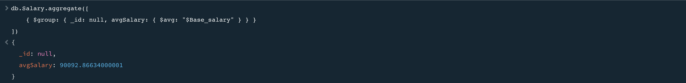

1. **Find employees who have worked on a project for more than 100 hours.**

* db.works_in.find({ "Hours": { $gt: 100 } }, { "ID_emp": 1 })

1. **Find the total number of employees who have completed the I-9 form.**

* db.I9_Form.countDocuments({})



1. **Find Employees with the Highest Salary**

* db.salary.aggregate([
* {
* $sort: { "Base_salary": -1 }
* },
* {
* $limit: 1
* },
* {
* $lookup: {
* from: "Employee",
* localField: "ID_Emp",
* foreignField: "ID_Emp",
* as: "employee_info"
* }
* },
* {
* $project: {
* _id: 0,
* employee_info: {
* $arrayElemAt: ["$employee_info", 0]
* },
* base_salary: "$Base_salary"
* }
* },
* {
* $project: {
* employee_name: {
* $concat: [
* "$employee_info.first_name",
* " ",
* "$employee_info.last_name"
* ]
* },
* base_salary: 1
* }
* }
* ]);

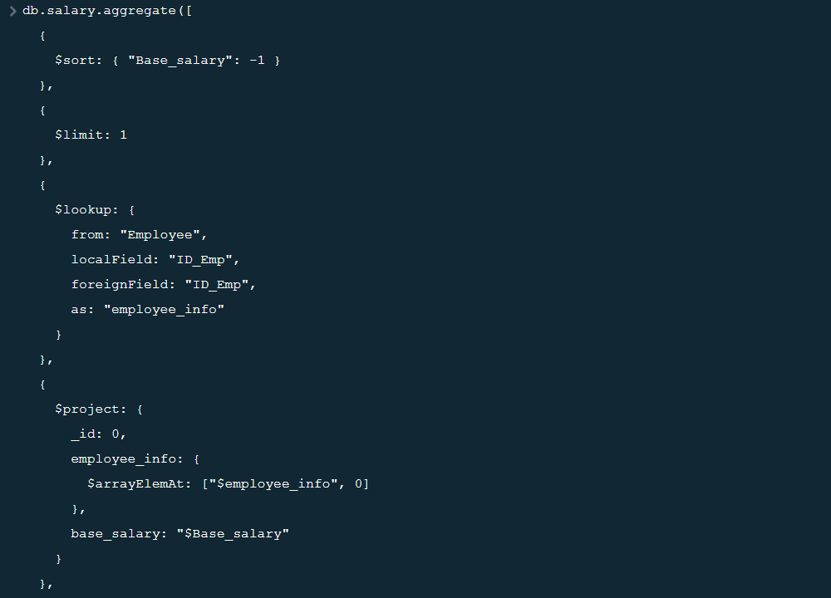

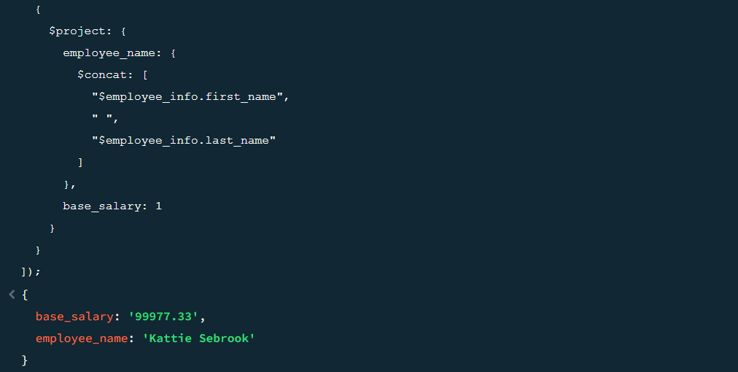

1. **Retrieve a list of the top 30 employees with the highest total budget utilization, including their full names and the corresponding total budget**

* db.budget.aggregate([
* {
* $match: {
* $and: [
* { "Total_Acc_amt_$": { $ne: "" } },
* { "Total_Acc_amt_$": { $type: "double" } }
* ]
* }
* },
* {
* $addFields: {
* Total_Acc_amt_numeric: { $toDouble: "$Total_Acc_amt_$" }
* }
* },
* {
* $group: {
* _id: "$ID_Emp",
* total_budget: { $sum: "$Total_Acc_amt_numeric" }
* }
* },
* {
* $sort: { "total_budget": -1 }
* },
* {
* $limit: 30
* },
* {
* $lookup: {
* from: "Employee",
* localField: "_id",
* foreignField: "ID_Emp",
* as: "employee_info"
* }
* },
* {
* $unwind: "$employee_info"
* },
* {
* $project: {
* _id: 0,
* employee_name: {
* $concat: [
* "$employee_info.first_name",
* " ",
* "$employee_info.last_name"
* ]
* },
* total_budget: "$total_budget"
* }
* }
* ]);

